**EX: 1-D Rocket Dynamics**

**Introduction**

In this study, a rocket dynamics analysis was conducted, where the speed, position, acceleration, flight duration, and maximum altitude of the rocket during its flight could be observed.

**diyagram, ekran görüntüsü, tasarım içeren bir resim

Açıklama otomatik olarak oluşturuldu**

(Fig.1. Rocket)

**Mathematical formulas**

$\sum{F_{x}=F_{T}-W-F_{D}}$ = $m_{rocket}*a_{rocket}$

$$F_{D}=\frac{1}{2}*ρ*V^{2}*S*C_{d}$$

$$W=m_{rocket}*g$$

$F_{T}$: Thrust force (1500N)

$F_{D}$: Drag force (N)

$C_{d}$: Drag coefficient (0.5)

$a_{rocket}$: Acceleration of rocket

m : mass (30 kg)

S : The reference area of the rocket (m^2)

V : Velocity (m/s)

$g=9.81 m/s^{2}$: Gravitational acceleration

d : Diameter of the rocket (120 mm)

t : Burning time (5sec)

W: Weight (m*g)

Let's model the flight dynamics according to the equation given above.

**Simulink**

Drag Force model:

diyagram, çizgi, öykü gelişim çizgisi; kumpas; grafiğini çıkarma, ekran görüntüsü içeren bir resim

Açıklama otomatik olarak oluşturuldu

(Fig.2. Drag Force)

Model the Weight:

diyagram, ekran görüntüsü, çizgi, dikdörtgen içeren bir resim

Açıklama otomatik olarak oluşturuldu

(Fig.3. Weight model)

Thrust Force model:

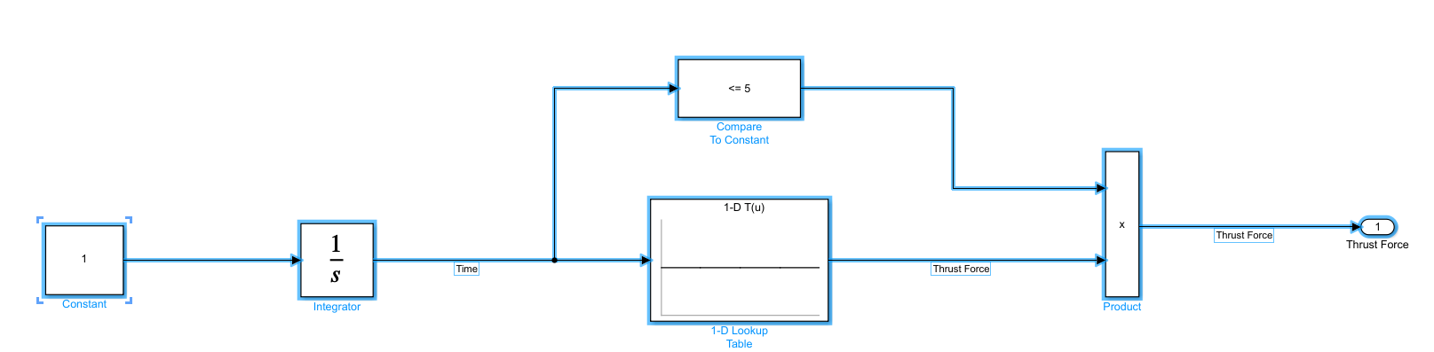

(Fig.4. Thrust Force)

Model the Thrust, thrust force will be applied to the rocket for 5 seconds.

█1-D lookup Table:

Table Data: Thrust_Force 🡪 It will be defined in the command window afterwards.

Breakpoints1: [1:5] 🡪 For 5 seconds

metin, ekran görüntüsü, yazı tipi, sayı, numara içeren bir resim

Açıklama otomatik olarak oluşturuldu

(Fig.5. Lookup Table)

█ Compare to Constant: Compare the input signal with the specified constant. If it is within the specified range, output "1", otherwise output "0".

Operator: <=

Constant value: 5

Then,

If the following formulas modelled, the acceleration of rocket could be found.

metin, diyagram, ekran görüntüsü, dikdörtgen içeren bir resim

Açıklama otomatik olarak oluşturuldu

(Fig.6. Acceleratiion)

**The final version of the model.**

Below is the final version of the model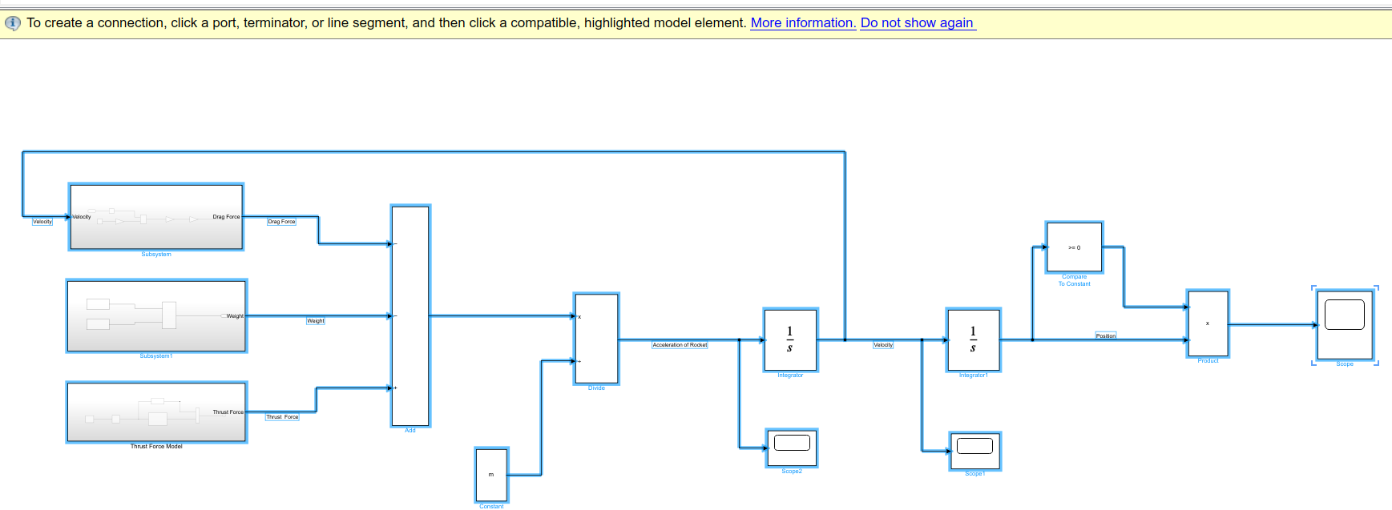

(Fig.7. Final model )

**Entering the parameters in the command window.**

>> Thrust_Vector = [1500 1500 1500 1500 1500]; %% Average Force for every seconds

>> rho = 1.225; %%assumed to be at sea level (kg/m^3)

>> m = 30; %% mass(kg)

>> Cd = 0.5; %%Drag coefficient

>> d = 0.12; %%Diameter of the rocket (m)

>> S = pi*d^2/4 %%Referance area(m^2)

>> g = 9.81; %%Gravitational acceleration(m/s^2)

metin, ekran görüntüsü, yazılım, çizgi içeren bir resim

Açıklama otomatik olarak oluşturuldu

(Fig.8. Parameters)

A Simulink model for rocket flight dynamics has been prepared. From now on, the system can be executed and the results can be interpreted.

**Scope**

ekran görüntüsü, çizgi, multimedya yazılımı içeren bir resim

Açıklama otomatik olarak oluşturuldu

(Fig.9. Scope)

**Conclusion**

In this study, a 1-D rocket dynamics analysis has been conducted, and the application is considered to be educational. Looking at the results, the rocket designed based on the values provided to the system is capable of reaching an altitude of over 2000 meters and returning to the ground after 42 seconds. The maximum speed is achieved at around the 5th second, reaching nearly 200 m/s, and then it can be observed to decrease. The acceleration can also be read from the graph. In conclusion, the design of a simple rocket can be achieved using this simulation.